**Module 4 – JUnit Testing Exercise**

**Exercise 1: Setting Up Junit**

**Scenario:** You need to set up JUnit in your Java project to start writing unit tests.

**Structure:**

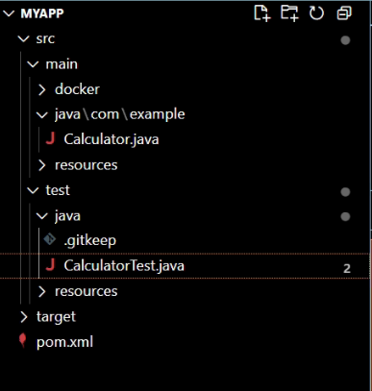

**CODE:**

**pom.xml:**

<project xmlns="http://maven.apache.org/POM/4.0.0"

         xmlns:xsi="http://www.w3.org/2001/XMLSchema-instance"

         xsi:schemaLocation="http://maven.apache.org/POM/4.0.0

         http://maven.apache.org/xsd/maven-4.0.0.xsd">

  <modelVersion>4.0.0</modelVersion>

  <groupId>com.example</groupId>

  <artifactId>mockito-demo</artifactId>

  <version>1.0-SNAPSHOT</version>

  <properties>

    <maven.compiler.source>11</maven.compiler.source>

    <maven.compiler.target>11</maven.compiler.target>

  </properties>

  <dependencies>

    <!-- SLF4J API -->

    <dependency>

        <groupId>org.slf4j</groupId>

        <artifactId>slf4j-api</artifactId>

        <version>1.7.30</version>

    </dependency>

    <!-- Logback as the SLF4J binding -->

    <dependency>

        <groupId>ch.qos.logback</groupId>

        <artifactId>logback-classic</artifactId>

        <version>1.2.3</version>

    </dependency>

</dependencies>

<build>

    <plugins>

        <plugin>

            <groupId>org.codehaus.mojo</groupId>

            <artifactId>exec-maven-plugin</artifactId>

            <version>3.0.0</version>

            <configuration>

                <mainClass>com.example.LoggingExample</mainClass>

            </configuration>

        </plugin>

    </plugins>

</build>

</project>

**Calculator.java:**

package com.example;

public class Calculator {

public int add(int a, int b) {

return a + b;

}

}

**CalculatorTest.java:**

package com.example;

import org.junit.Test;

import static org.junit.Assert.*;

public class CalculatorTest {

@Test

public void testAdd() {

Calculator calc = new Calculator();

int result = calc.add(2, 3);

assertEquals(5, result);

}

}

**OUTPUT:**

